Jerry Carpenter
Brent Gullett
Kelsey Bradley
IET 120
February 22, 2010
Activity 2
Alternate Energy Source
Background: After carefully examining our everyday lives, we decided the energy source that needs the most improvement is our cars. We realize there has been several improvements made to the efficiency of internal combustion engines in recent years, but we still aren’t satisfied with the amount of money spent each month, just on fuel. With the instability of the crude oil market, you really don’t know if your going to pay $2.50 per gallon of gasoline or $4.50 per gallon the next time you fill up your tank. Given the uncertainty of gas prices, we concluded the best way to improve on fuel efficiency was to do away with fuel itself and use a free, unlimited resource. The design we devised uses wind to power vehicles.

Problem Solving Approach: Using wind as the primary energy source, cuts energy costs to virtually zero. The only time there would ever be any costs related energy would be if the battery bank charge were to drop below 30%, then the car would have to be charged using a conventional electric plug in your home.

Development of Alternative Solution: This system works by channeling air from the existing front spoiler (air dam) through high velocity duct system. The duct system is connected to a wind turbine that generates energy. The wind velocity and power generated will be directly related. Since the wind will be inconsistent, the power generated will also be inconsistent. In order to store the power it must be consistent. To stabilize the power, it must have a constant frequency and a constant magnitude. This will be achieved by using a voltage regulator. The voltage regulator will regulate the inconsistent power so the batteries can store the energy properly. The next step in the process will be to store this power in a DC battery bank. The battery bank will be connected to the accelerator which will consist of 2 variable resistors (potentiometers). As the driver accelerates, the potentiometers will decrease resistance, allowing more current to flow to the engine. As the driver decelerates, the potentiometers will increase resistance, restricting the current flowing to the engine.
Not only will this energy source power the vehicle, it will also be converted to AC using a power inverter. This power will be available inside the vehicle to power any 110 V electrical items.

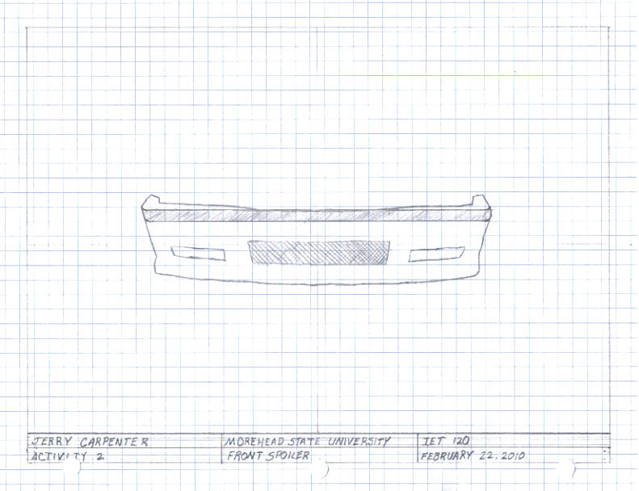

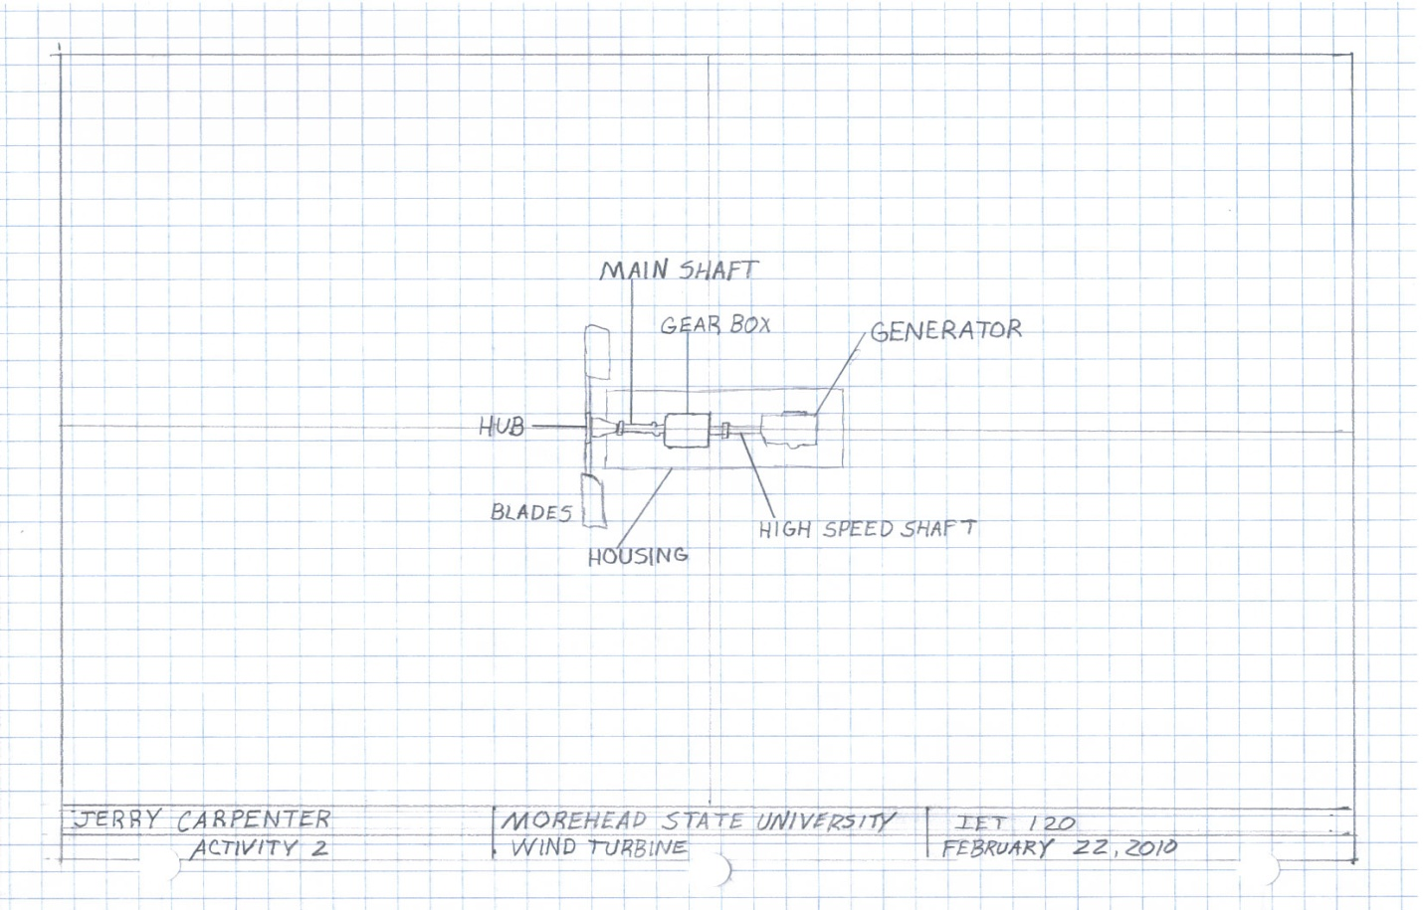
Works Cited
Dale Vince's wind-powered car could be the Storm, the Zero or the Nemesis â€” Autoblog Green. (n.d.). Autoblog Green â€” We Obsessively Cover The Green Scene. Retrieved February 18, 2010, from http://green.autoblog.com/2009/01/06/dale-vinces-wind-powered-car-could-be-the-storm-the-zero-or-th/
How Does a Wind Powered Car Work?. (n.d.). wiseGEEK: clear answers for common questions. Retrieved February 18, 2010, from http://www.wisegeek.com/contest/how-does-a-wind-powered-car-work.htm
The wind powered car project - a knol by gaby de wilde. (n.d.). Knol - a unit of knowledge: share what you know, publish your expertise.. Retrieved February 19, 2010, from http://knol.google.com/k/the-wind-powered-car-project
Wind Power - Converting wind energy into electricity. (n.d.). Alternative Energy News. Retrieved February 20, 2010, from http://www.alternative-energy-news.info/technology/wind-power/

