ETM 419/619
Fall 2016
IA 2
40 Points

- When using a Cause-and Effect (Fishbone) Diagram as a problem-solving tool during brainstorming, what particular action must be ensured? (5 points)
They must focus on the problems that are relevant to the situation at hand.
- In what way does a Scatter Diagram provide justification for determining a mathematical model that relates the variables being studied or analyzed? (5 points)
Scatter diagrams are useful for finding patterns. If a relationship is found in the scatter diagram, it cannot be inferred that one variable is the cause of the other, but it can provide graphical evidence that the relationship is real and will provide some knowledge regarding the strength of the relationship. The strength of the relationship is determined by the variability of the cluster of points relative to the mathematical expression describing the association.
- The following measurements were collected hourly from two production processes. Construct a Run Chart for Process A and describe the general trend. (15 points)
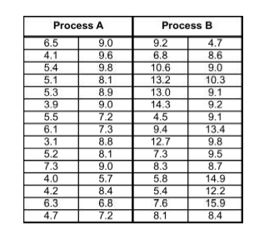

The first half of the day shows that the process was performing under the average of 6.65. The second half of the day the process was performing at or above average.
- The following check sheet was constructed on 45 defective motors identified during a final inspection process in a small electronics plant. (15 points)
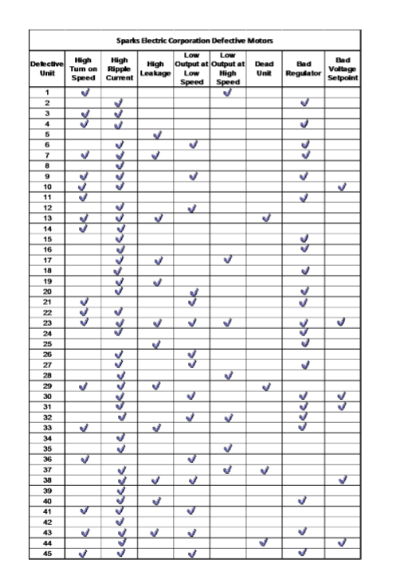
- Construct a Pareto chart for these data.

- Which problems appear to deserve the most attention? Why?
The problems that deserve the most attention are High Ripple Current, Bad Regulator, High Turn On Speed, and Low Output at Low Speed. They deserve the most attention because they are within the 20% which means they are key issues.

