ETM 419/619

Fall 2016

Individual Assignment 3

1. (5 Points) Describe the difference between chance and assignable causes.

Chance causes consist of many different individual causes. Assignable causes consist of a couple of causes that can be pinpointed to the problem. (page 241)

1. (10 Points) Androx Chemicals manufactures a powdered compound that is used to coat gunite swimming pools. An important measure is the Dry Brightness (DB) Number, and customers will not accept product that has a DB number less than 90.3. Because it is difficult to obtain a precise reading, a technician takes a grab sample of material, divides it into three parts, and then measures each part. The three measurements are then averaged and plotted on control charts. The following data represent 20 samples that were obtained from this process. Use control charts to determine if the process is in control. Show calculations use to find X bar, UCL, LCL, etc.

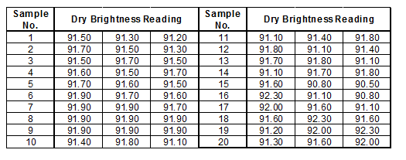



TEST 1. One point more than 3.00 standard deviations from center line.

Test Failed at points: 16

TEST 2. 9 points in a row on same side of center line.

Test Failed at points: 9, 18, 19, 20

This process is not in statistical control, because there are places where the tests failed.

1. (15 points) The following times were recorded for a bagger at a local grocery store.

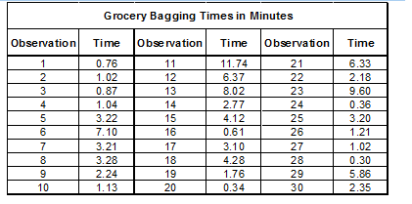

1. Construct a histogram and comment on shape.

The histogram shows that the bagging times are non normal.



1. What is your estimate of the mean and standard deviation for the data? Show calculations.

**Descriptive Statistics: C1**

Variable N N* Mean SE Mean StDev Minimum Q1 Median Q3 Maximum

C1 30 0 3.313 0.537 2.942 0.300 1.020 2.560 4.675 11.740

1. Plot an *X* and *MR* pair of control charts and comment on the state of control. Show calculations used.



**Test Results for I Chart of C1**

TEST 1. One point more than 3.00 standard deviations from center line.

Test Failed at points: 11

**Test Results for MR Chart of C1**

TEST 1. One point more than 3.00 standard deviations from center line.

Test Failed at points: 11

1. (5 points) A certain mineral is inspected for particle size. Since particles tend to separate out, a sample is taken from four different locations in the storage silo. The four samples are then averaged. The results of 30 samples are shown in the table.

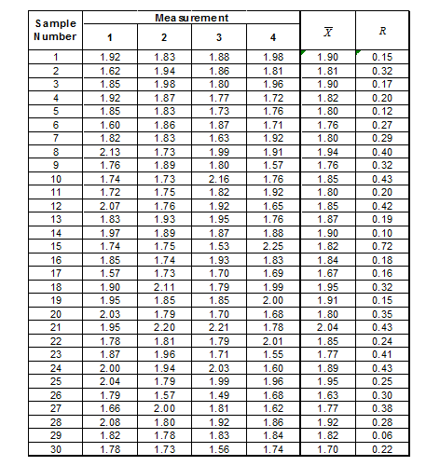

Construct an  chart for these data and comment on whether this process is in statistical control.



**Test Results for R Chart of C1, ..., C4**

TEST 1. One point more than 3.00 standard deviations from center line.

Test Failed at points: 15