ITCD 405 - Civil Drafting
Assignment 1
Due: Monday, January 31 2011
- Submit assignment as hard copy (please hand in after printing). Show Dimension as well.
- Extra credit will be given for sending electronic copy too
Remember to write your name, date and assignment on the bottom of the drawing (like below)
Draw side elevation, front elevation, Floor Plan, Isometric view and section AA of building
Use 20 ft wide, 30 ft Length and 35 ft height of building. Thickness of outside wall is 10 inch. Use other appropriate dimensions.
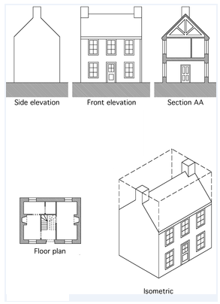
Section AA

