ITCD 405 - Civil Drafting
Assignment 2
Due: Monday, February 7 2011
- Submit assignment as hard copy (please hand in after printing). Show Dimension as well.
- Send electronic copy too
Remember to write your name, date and assignment on the bottom of the drawing (like below)

- Draw the following item of given building using AutoCAD software
- Site plan
- Floor plan
- Elevation (Front, Rear, Side)
- Cross section
Use appropriate dimension of door, window, wall (10”), cross section (if dimension is missing)
- Show missing door and windows on floor plan
- Show all dimensions at site plan, floor plan, elevation and cross sections
- Specify Front, Rear, Side Elevation according to drawing
- Draw Isometric view of building

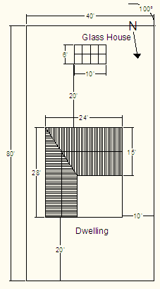
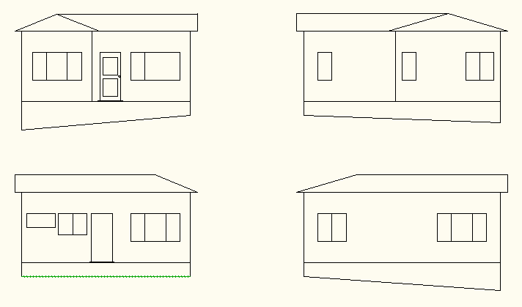
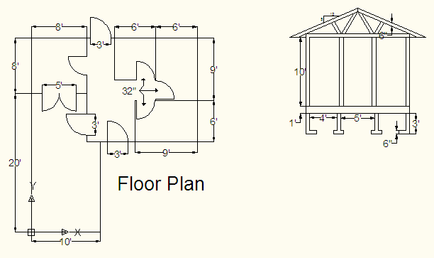
Cross Section AA
Section AA

