ITCD 405 - Civil Drafting
Assignment 3
Due: Wednesday, February 16, 2011
- Submit assignment as hard copy (please hand in after printing). Show Dimension as well.
- Send electronic copy too
Remember to write your name, date and assignment on the bottom of the drawing (like below)

- Draw the following using A+CAD software
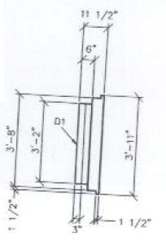
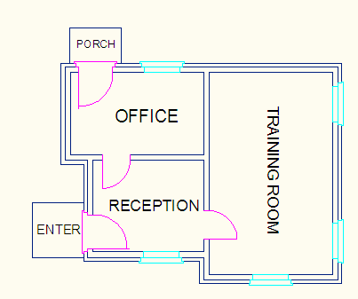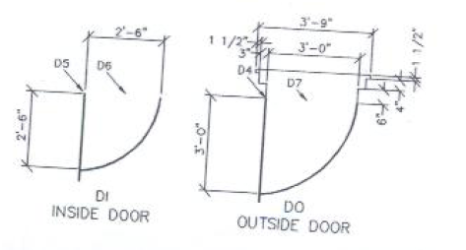
Window
Use different layer of door, window, wall and text.
Use block of outside door, inside door and windows

- Dimension of building plan is showing below:
Wall thickness is 6” and Cladding is 4”
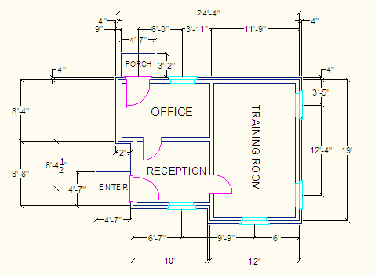
- Add layer of desk and chair like this:
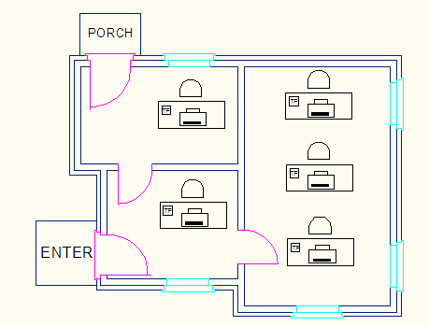
Use block command to draw desk and chair:
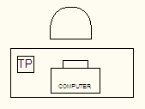
- Add another layer of desk and chair like this:
Use block command to draw table and chair
