ITCD 405 - Civil Drafting
Assignment 5
Due: Wednesday, March 9 2011
Submit assignment as hard copy (please hand in after printing). Send electronic copy too
- Draw the following drawing of given using Carlson CAD software
- Find area of plot and traverse (Six drawings). Show north arrow.
- 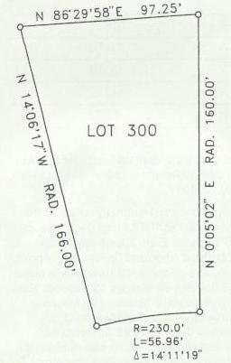
- 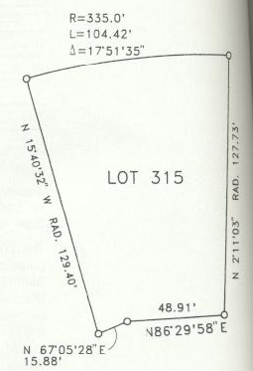
- 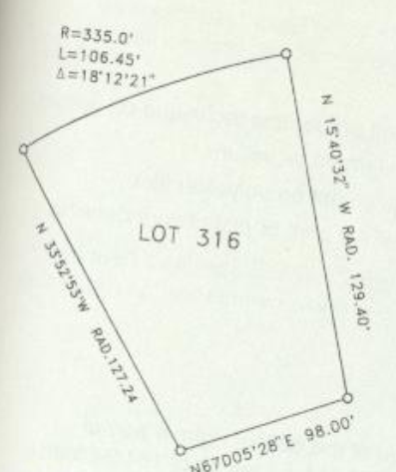
- 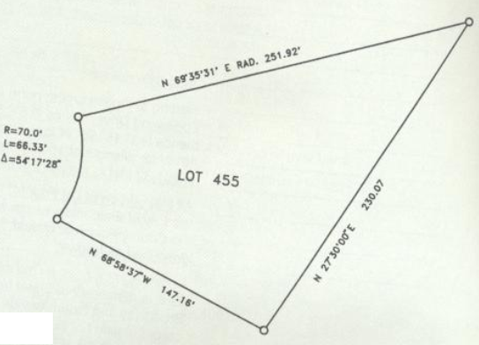
- 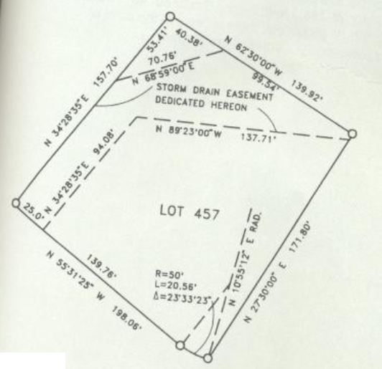
F.)

