IMPROVING EFFICIENCY AND PRODUCTIVITY AT SEALMASTER: INDIVIDUAL REPORT

FOR
DR. NI WANG
IET 330
SPRING 2015

KELSEY BRADLEY
M0821671
MOREHEAD STATE UNIVERSITY
05/01/2015

Our project was focused on improving the efficiency and productivity at SealMaster in Morehead, KY. They produce ball bearings for companies such as General Mills and Wayne Supply. Elizabeth McClain, one of my group members, works there. She came up with an idea that would decrease the time it takes to change out the tools on the CNC machines on the lines.
The design idea we chose was to get rid of the tool rack and add shelves to the current workstation for the placement of the tools. This would decrease the amount of time it takes to change out the tools. It also would create less fatigue for the machine operator, as well as making more money for SealMaster. We planned to accomplish this task by using the following Gantt Chart.
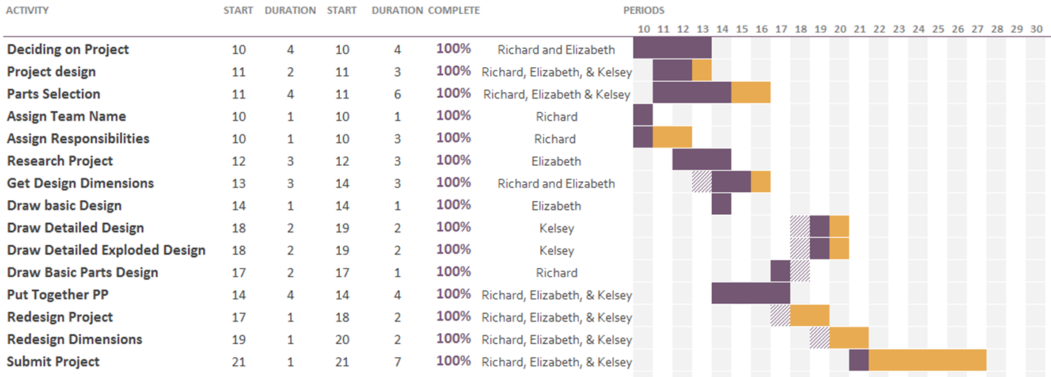
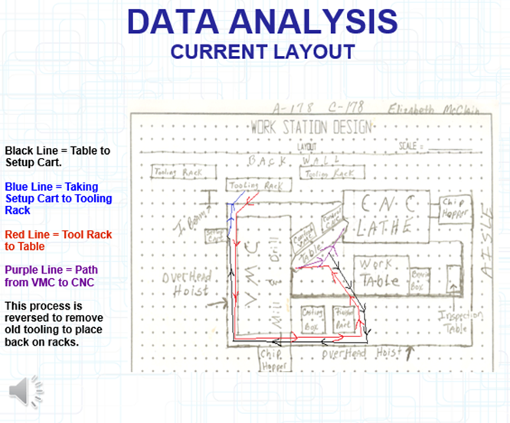
From mid-March to early April, we were able to collect data on the current process of changing out the tools on the CNC machine at SealMaster.
The data was obtained by timing the operators at each step of the process of manufacturing the P313 ball bearing. It can be seen in the table below:
Our goal was to cut down on the time and effort it takes to set up the workstation by eliminating the amount of steps necessary to get the machine ready. We were able to achieve this by building two shelves into the existing workstation, which would hold the tools required to operate the machines. This eliminates the need for the tooling rack and creates more floor space in the factory. It also generates more money for the factory due to the increased rate of productivity from the operators of the machines.
Tooling Rack
Current Workstation

Our designs were created in SolidWorks. They can be seen in the images below:
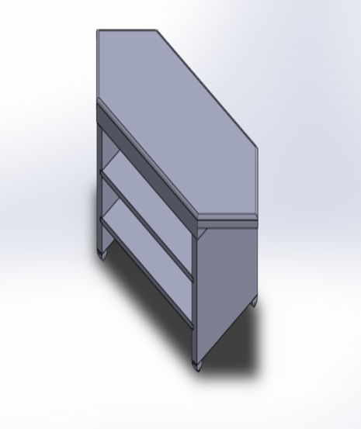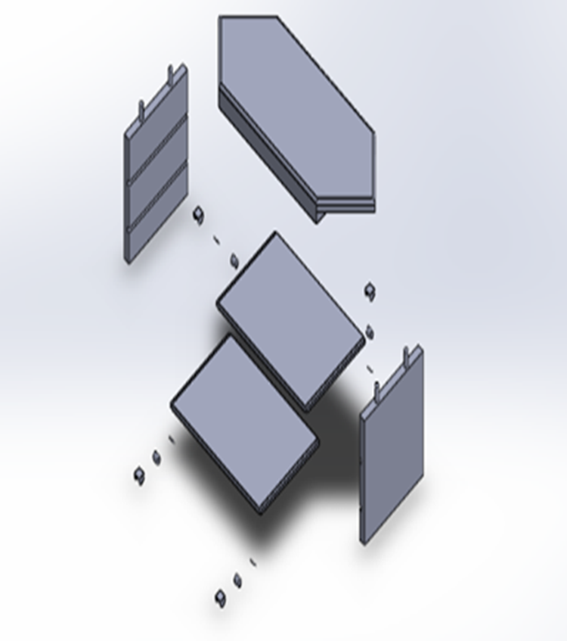

The time saved can be seen in the image below:
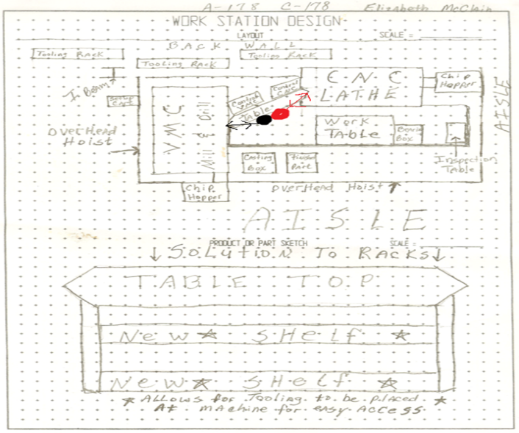

The revised data shows how much time can be saved by changing the current process. By adding the shelves, a little over 4 minutes can be saved each time. The data can be seen below:
In conclusion, our design simplified the process of changing out the tools and made more money for the company. Elizabeth has presented it to SealMaster, and they have approved the changes. They are currently in the process of implementing the new design. They have saved even more money by being able to use the in house welder that works at SealMaster. We were happy to find out that they took our idea seriously and were able to implement it in the factory.

CONTRIBUTIONS
I used SolidWorks to create the CAD drawings of the project. The drawings can be seen below. I also polished the PowerPoint as well as added the audio for it.

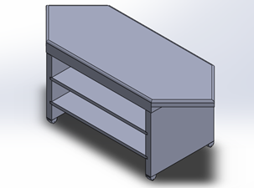
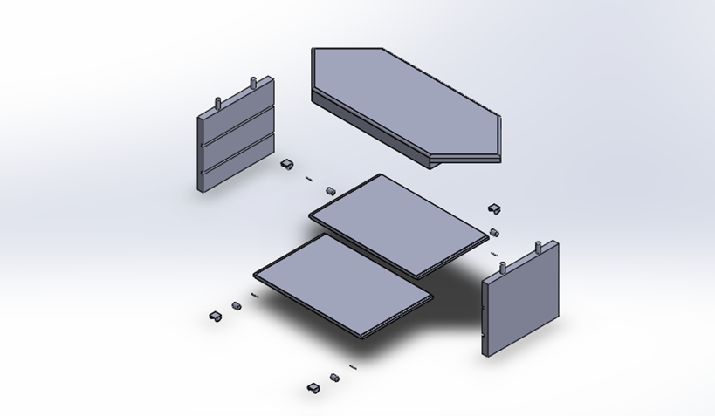
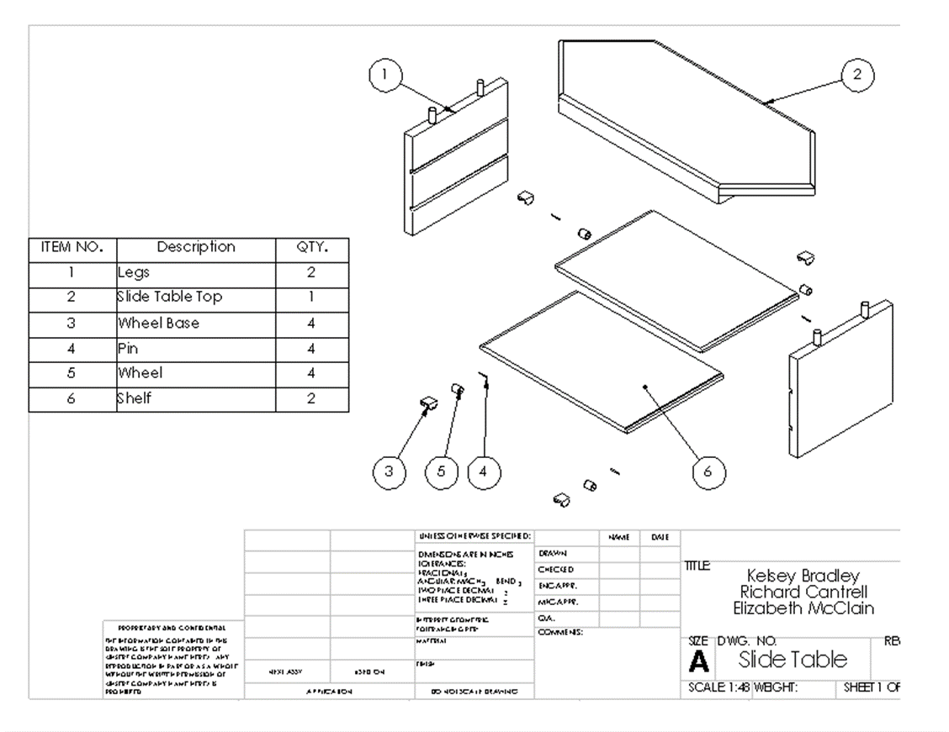
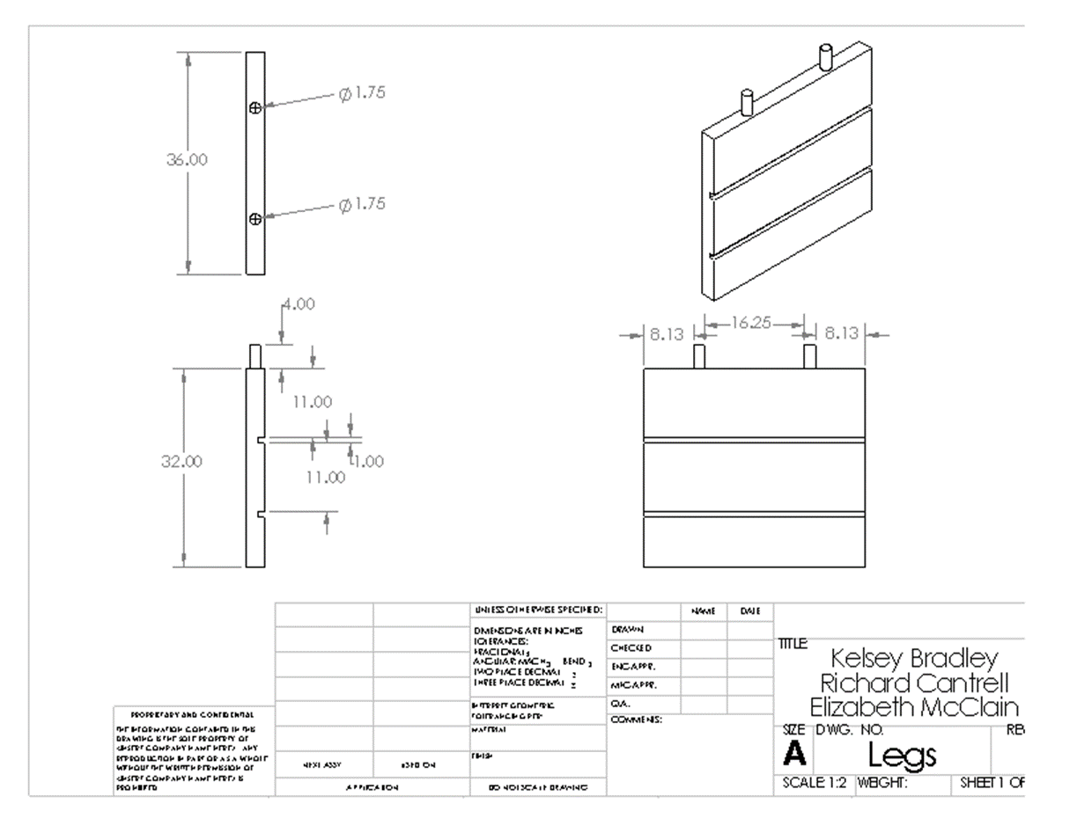
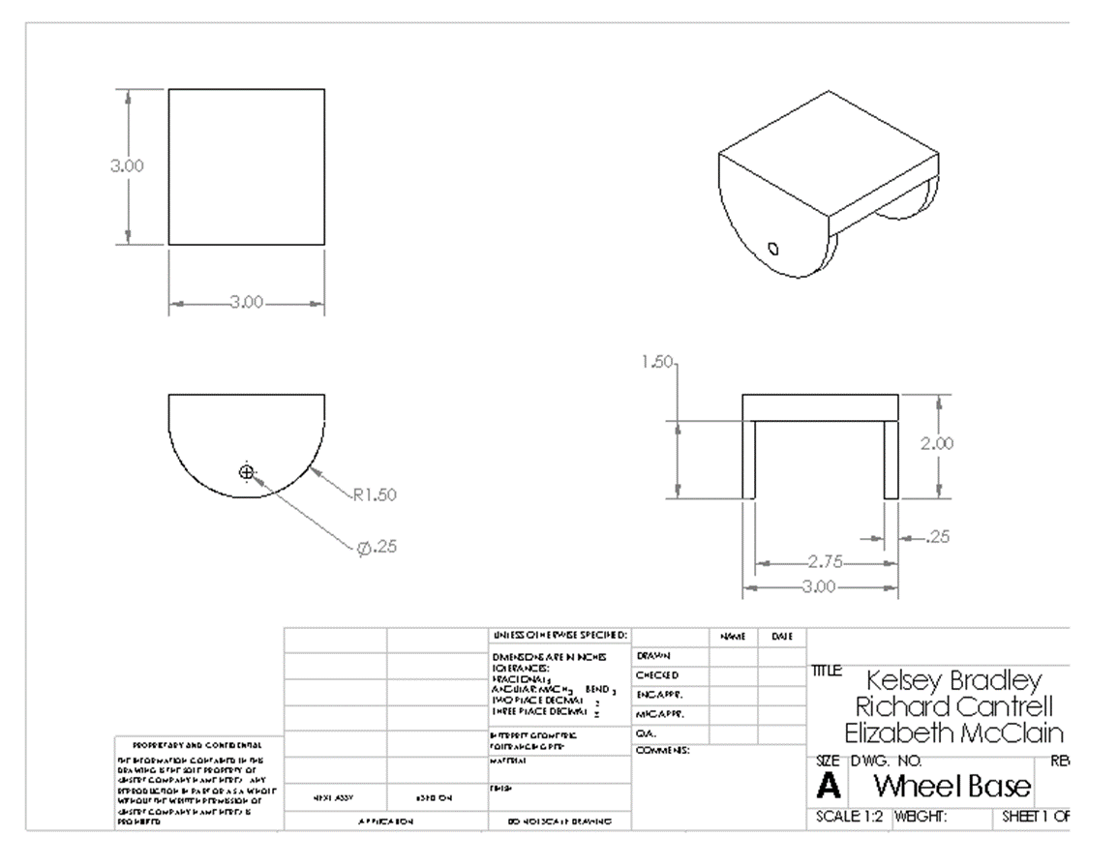
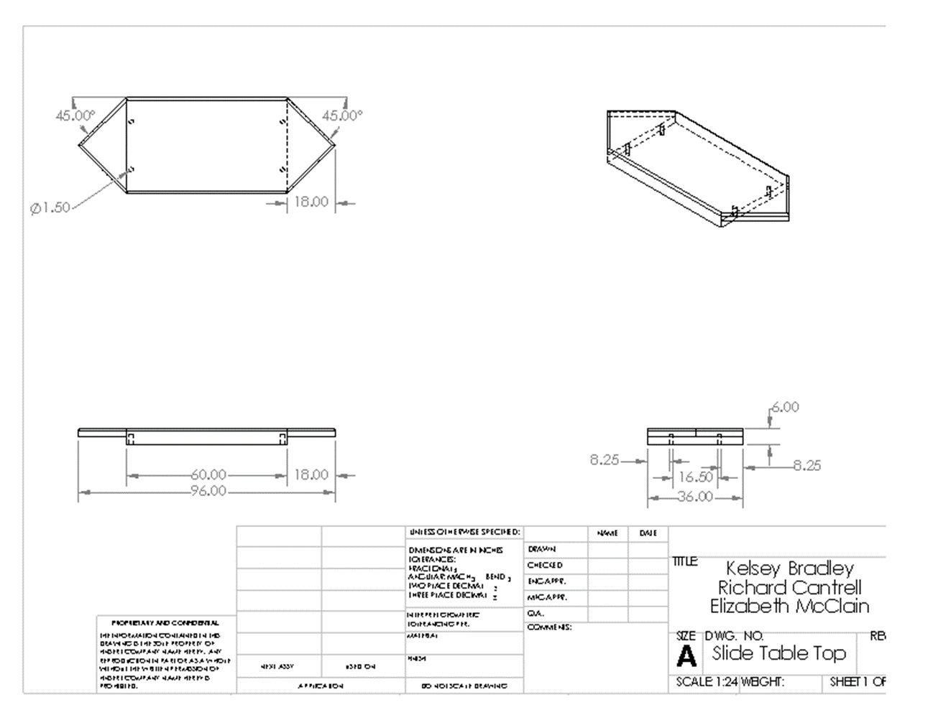
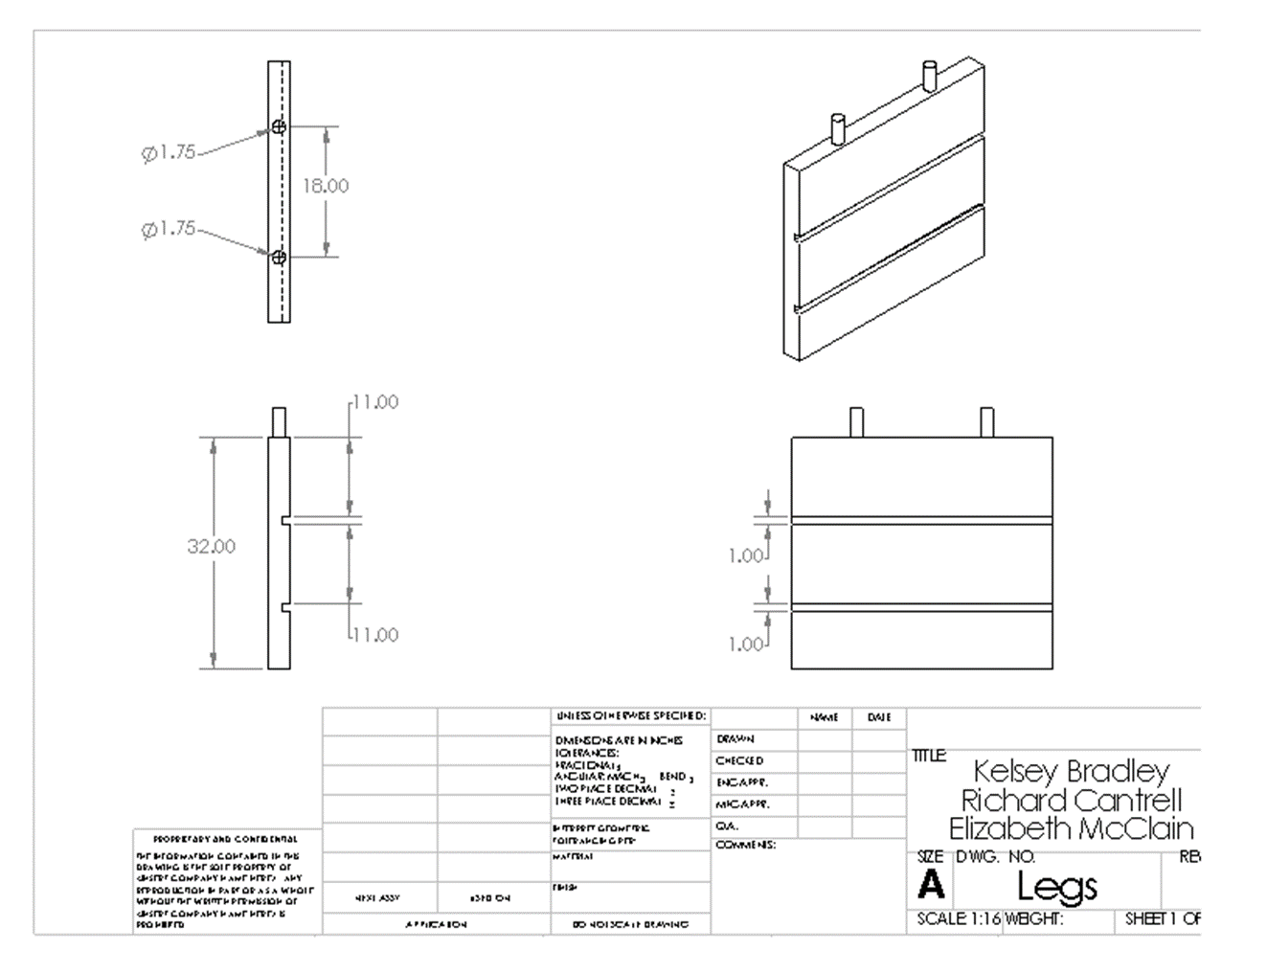
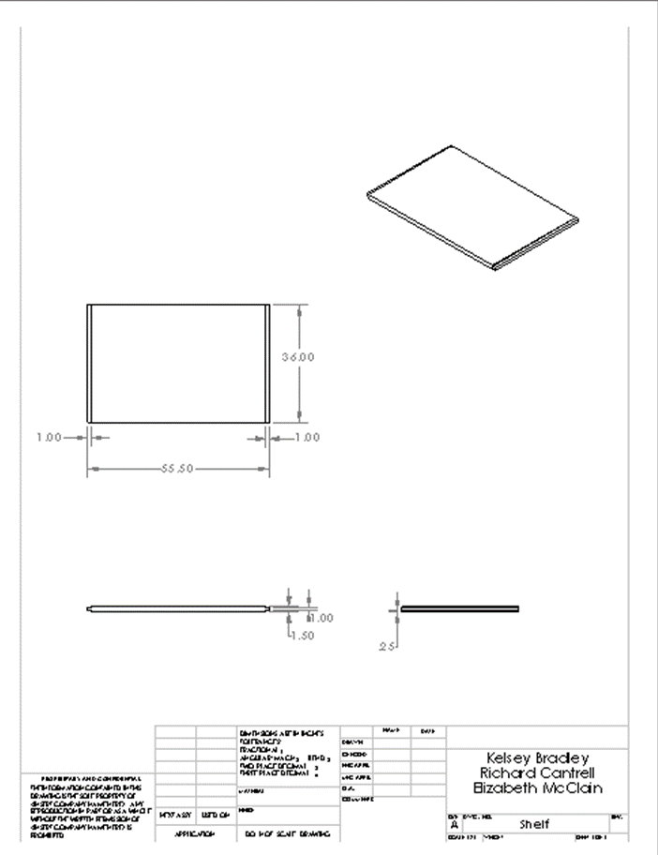
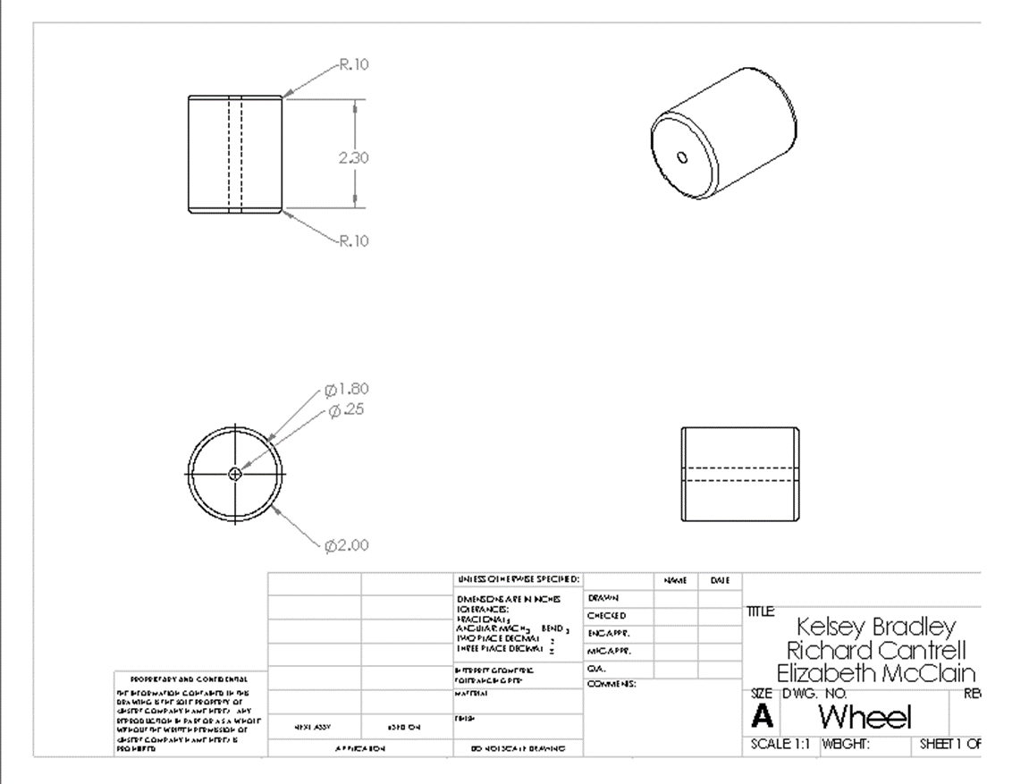
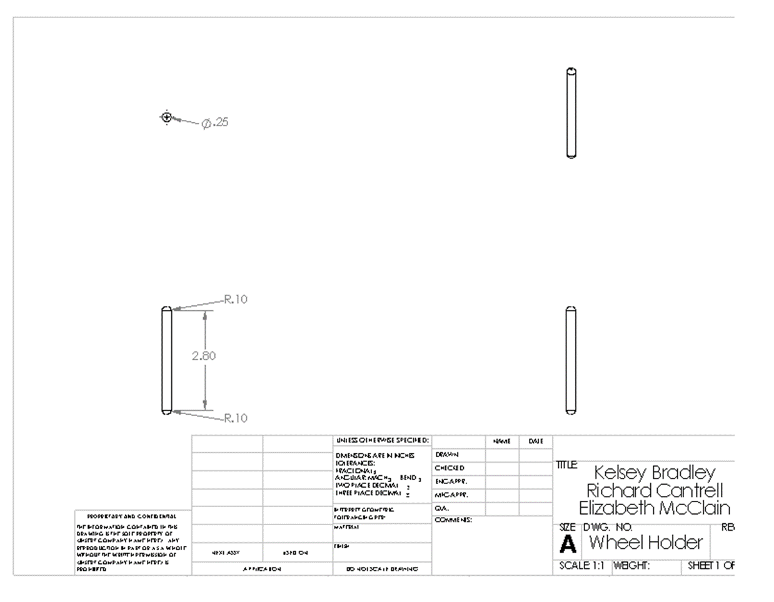

SELF EVALUATION
Although I got off to a late start, I feel like I was able to significantly contribute to the overall project completion. I was responsible for the CAD drawings and the audio in the PowerPoint. I also put the finishing touches on the PowerPoint. I believe that we all pulled our weight on this project. I also feel like we are each deserving of a good grade. We were able to create a design that is actually in the process of being implemented by SealMaster. This is awesome!

