Digital Terrain Modeling:
A Digital Terrain Model (DTM) represents the topography ( the earth’s surface)of a project in the form
of a triangulated network. Digital terrain Models can be generated from various sources including elements, survey data, photogrammetric data, Power Civil cross-sections, and geometry data.
The DTM tool frame can be accessed by selecting the DTM tool from Civil> DTM.
Extraction of Input Data:
DTM can be created from a wide range of data sources including CAD elements, survey data and ASCII data.
An extract tool is included to ease the retrieval and formatting of CAD graphical elements. These elements can be classified as contours, random points, break lines, voids, islands, and boundary points.
Exercise:
- Open the power design file. [Data\Geo\Site\Site 1\ Chapter8\Contours.dgn] by choosing File> Open n the main menu bar.
- Select the DTM Tools frame from the civil tool or by Civil> Digital Terrain Model.

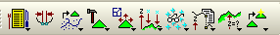

- Click the DTM Menu from the DTM Tools.

4)Select the Extract Graphics tool. [DTM menu: extract > Graphics]

- Enter the Extract Graphics information as seen below:

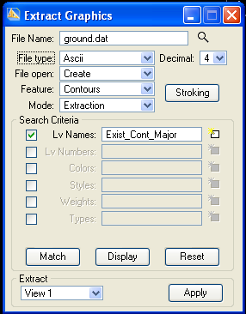

5) Click Match, then click the check box next to Lv Names and then Select Levels to right of Lv Names . Select and accept one of the minor contour lines.
6) Click Display.
This shows all the contours that matched the level name of the one selected, seen at right.
7) Go through the same process ( #5 & #6) and this time choose one of the major contour lines.
8) Choose both the major and minor lines.
9) Set Extract to View 1.
10) Click the Fit View tool from the Power Civil View Control tools.
11) Click Apply on the Extract Graphics dialog.

The graphical CAD information has now been extracted and the resulting data has been stored in a file named “ ground.dat”.

Generating a Triangulated Model
Creating a triangulated model is the most important piece of constructing the DTM. The triangles created in this process represent the ground surface for the contours that are already in place. All the resulting models and calculations are derived from this core triangulated model.
The triangulated model created is stored in a file called a TIN.
Building Triangles:
- Select the Build Triangles tool. [ DTM Menu: Build > Triangles]
- Enter the information at the Build Triangles box as follows.
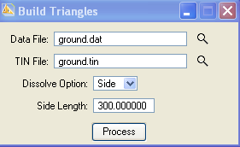
- Click Process.

Display and Draw TIN Features:
PowerCivil has a wide variety of options to provide you with maximum flexibility when drawing and displaying DTM features. The source data can be the DAT file, TIN file or Lattice file.
Different DTM features can be loaded, then displayed or drawn, depending on the type of source file. As the file is selected, the DTM features automatically change to reflect the selection.

Drawing Contours and Triangles:
- Select the Load DTM Features tool. [ DTM Menu: Load > DTM features] and enter the first two line data as table below:
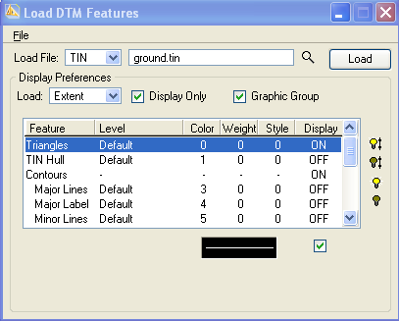
- Double click the Triangles row to turn Display on.
- Double click on the sample graphic to set the Triangle Display parameters as seen below:
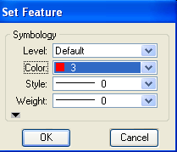
- Select the Contours row and turn Display on.
- Click Read. (This establishes the minimum and maximum elevation range of your TIN file.
- Enter the counter information in bottom of dialog as seen below.
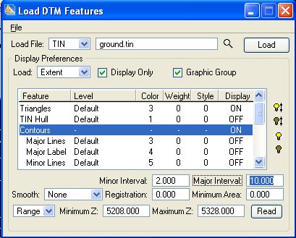

- Individually highlight Major Lines, Major Label, and Minor Lines items and turn Display on.
- Set display preferences for each item as seen below:

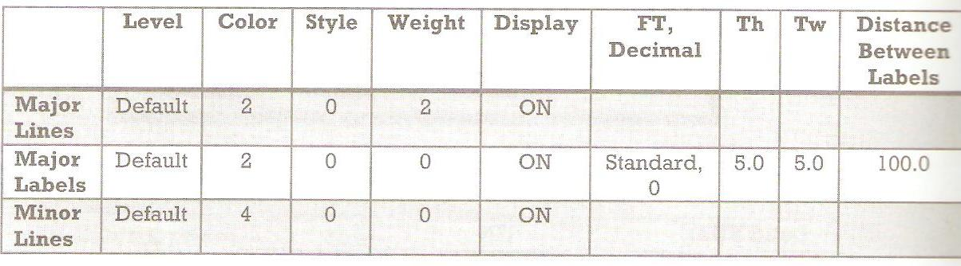

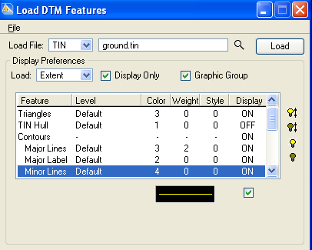
- Click Load. Once clicked, the contours should change to green or yellow while the triangles appear in red.
- Close dialog. Once you close this dialog the triangulated model will no longer be visible.
Note: The “display only” option has been enabled. To draw the DTM features into the CAD file permanently, you can disable the “display only” option and click “Load”.
Editing Triangles:
Many tools to interactivity edit TIN models are located in the TIN edit Tools dialog. The triangulated model can be edited in terms of adding, deleting, or moving spot elevations. As editing is initiated, resultant triangles, contours, flow arrows and voids are optionally displayed as you go.
The list box on the left side of the dialog contains the editing options. As each tool is selected, the right side of the dialog changes to reflect the current tool. All these editing features show the changes as they occur. In addition, the changes are not written permanently to the triangulated model until you select the Save button. This allows you the option of saving your modifications
(Save) or rejecting the modifications (Undo to last Save).
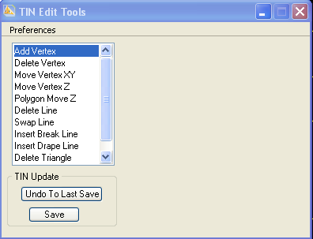

Digital Terrain Model Analysis Tools:
Located on the DTM tool frame the analysis tools can be opened as its own tool frame ( as seen below) by clicking on the black arrow in the bottom right hand corner and choosing ‘Open as Toolbox’
The Analysis tool box contains eleven tools as follows:
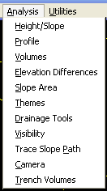
The Analysis Tools are an excellent way for you to gain instant answers from the TIN surface for a wide range of analysis questions.
Height Tool:
The height tool allows you to see, while in a plan view, the coordinates, elevation and slope of the triangulated model. The Height dialog automatically updates for each successive user defined data point.

Verifying Elevations:
- Select the Saved Views tool. [ In utilities menu]
- Select ANALY and click Apply. Then choose the dialog.
- Select the Height tool.

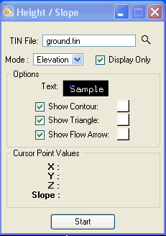

- Enter information as seen below.
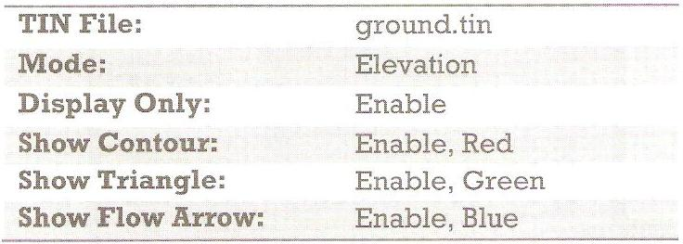

- Click Start. You can now click at any location where you would like to know the elevation.
- Click in several locations to show the elevation, contour and flow direction information.
The cursor point values are constantly updated.
- Reset when finished, by right clicking.
- Close the height dialog.

