IET330-301_Dr. Ni Wang_ Spring 2015
Student Name: ________
Individual Assignment_Configuration & Parameter Design
- List ten types of geometric features that can be configured on a special purpose part? Find pictures for at least 5 geometric features.

-walls
-holes
-fillets
-slots
-chamfers
-rounds
-spurs
-points
-grooves
-edges

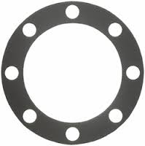
HOLES

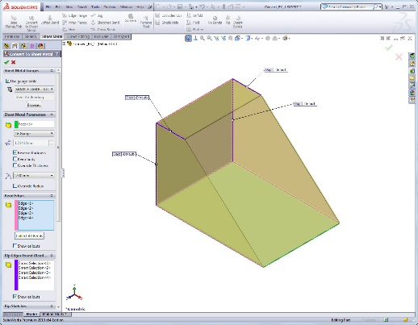
EDGES
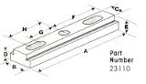
SLOTS

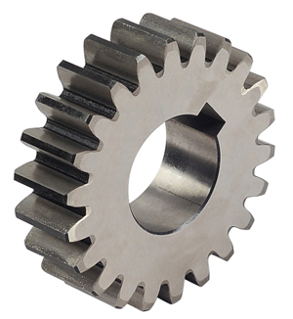
SPURS

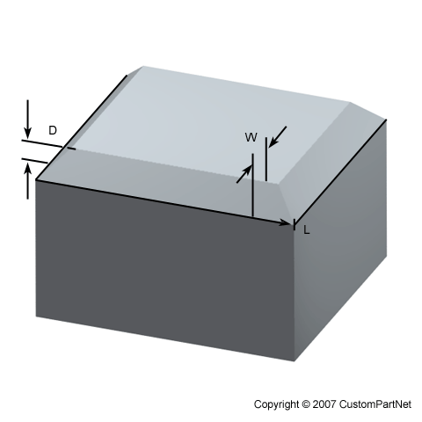
CHAMFER
- A customer would like to support a 1000 lb art sculpture on a column 20 feet high. You have been hired to complete the parametric design. The customer would be unhappy if the column buckled or cost too much. Your column, he further suggests, should be able to support a design load of 8000 lbs. Begin the parametric design by formulating the problem and complete the following tables.
Other Problem Information
- The force causing the first sign of buckling is the critical load P_{cr..} according to Euler’s buckling formula below. E= modulus of elasticity, I= moment of area(inertia), L= column length.
- E_{aluminum} = 10 Mpsi, E_{steel} = 30 Mpsi.
- Column available in different cross sections: circular, rectangular, box, and structural “H.”
- Column cost can be approximated by the following relation C = 35.6 I [$]

Solution Evaluation Parameter(s)
 | Parameter | Symbol | Units | Lower Limit | Upper Limit
1 | Critical load | Pcr | pounds | 8000
2 | Cost | C | US Dollar ($) | 0

Design Variable(s)
 | Design Variable | Symbol | Units | Lower Limit | Upper Limit
1 | Materials (steel and aluminum) | E | Mpsi | 10 | 30
2 | Moment of Area | I | in^4 | 0
3 | Cross section shape | The moment is a function of the chosen shape.

Problem Definition Parameter(s)
 | Parameter | Symbol | Units | Lower Limit | Upper Limit
1 | Pi | π | None
2 | Length | L | Ft | 20 | 20
3 | Weight | W | Lbs | 1000 | 1000

- Base on problem 2, if circular cross section is chosen, I (Moment inertia of circular) = $\frac{πd^{4}}{64}$ (d is the diameter of circular), determine the value d for this design.

