Lab 3
Differential Leveling

By: Kelsey Bradley

Group Members: Eric Dingess and Brent Gullett
OBJECTIVE
The objective of this lab is to learn how to measure different elevations and side shots using the equipment provided by the instructor. We also were required to show our notes and figure out the accuracy of our measurements.
EQUIPMENT
Philadelphia Rod
Auto Level
Steel Tape
MEASUREMENTS
Station | Sight + | HI | Sight - | Elevation | Distance
BM1 |  |  |  | 500.00
 | 3.10 | 503.10
Stairwell |  |  | 6.08 | 497.02
TP1 |  |  | 2.85 | 500.25 | 84.00
 | 2.44 | 502.69
TP2 |  |  | 6.56 | 496.13 | 108.00
Fire Hyd. |  |  | 1.73 | 500.96
 | 6.80 | 502.93
Combs |  |  | 6.74 | 496.19
TP3 |  |  | 4.47 | 498.46 | 48.00
 | 8.16 | 506.62
TP4 |  |  | 3.12 | 503.50 | 48.00
 | 8.66 | 512.16
TP5 |  |  | 4.20 | 507.96 | 80.00
Sign | 4.40 |  |  | 512.36
Steps | 4.02 |  |  | 511.98
 | 5.09 | 513.05
TP6 |  |  | 4.44 | 508.61 | 40.00
 | 4.12 | 512.73
TP7 |  |  | 6.70 | 506.03 | 48.00
WBF |  |  | 3.41 | 509.32
RHF |  |  | 2.78 | 506.39
 | 0.23 | 506.26
TP8 |  |  | 7.05 | 499.21 | 64.00
 | 4.46 | 503.67
BM1 |  |  | 3.94 | 499.73 | 60.00
 |  |  |  | Total Dist. | 580.00

$$\frac{0.27}{580}= \frac{1}{2148.15}$$

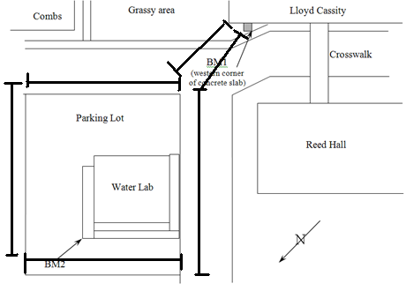
CONCLUSION
This lab was difficult to complete. The side shots were what made it hard to do. I got confused about what and where to write them in my notes. This lab helped me understand better what to do when surveying.

