IET330-301_Dr. Ni Wang_ Spring 2015
Student Name: KELSEY BRADLEY
Concept design
- Dissect a small appliance and create a physical decomposition diagram. Put all disassembled units together, and take a picture. Label each of them. Write a narrative accompanying the diagram to explain how the product works. (Hope there is no part left when you put them back).
INK PEN
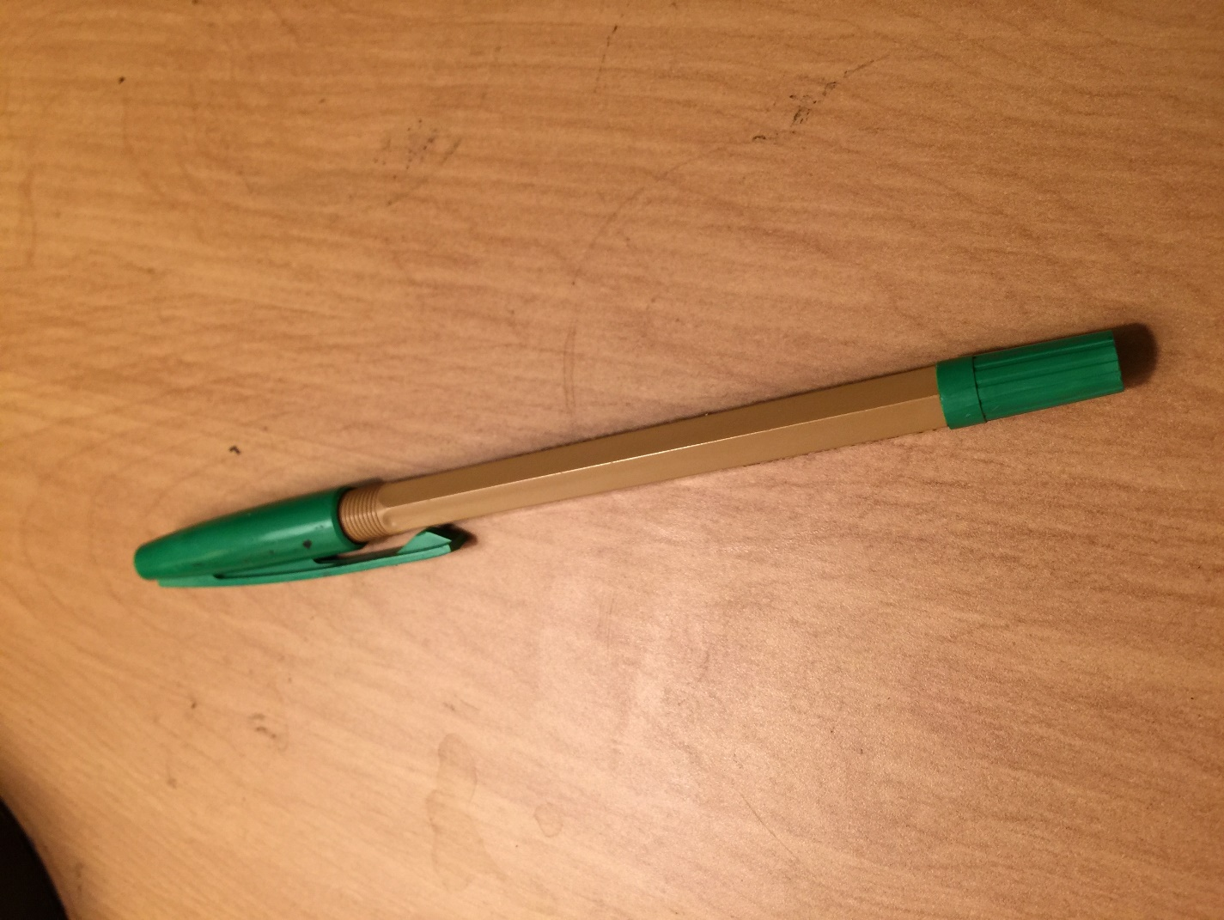

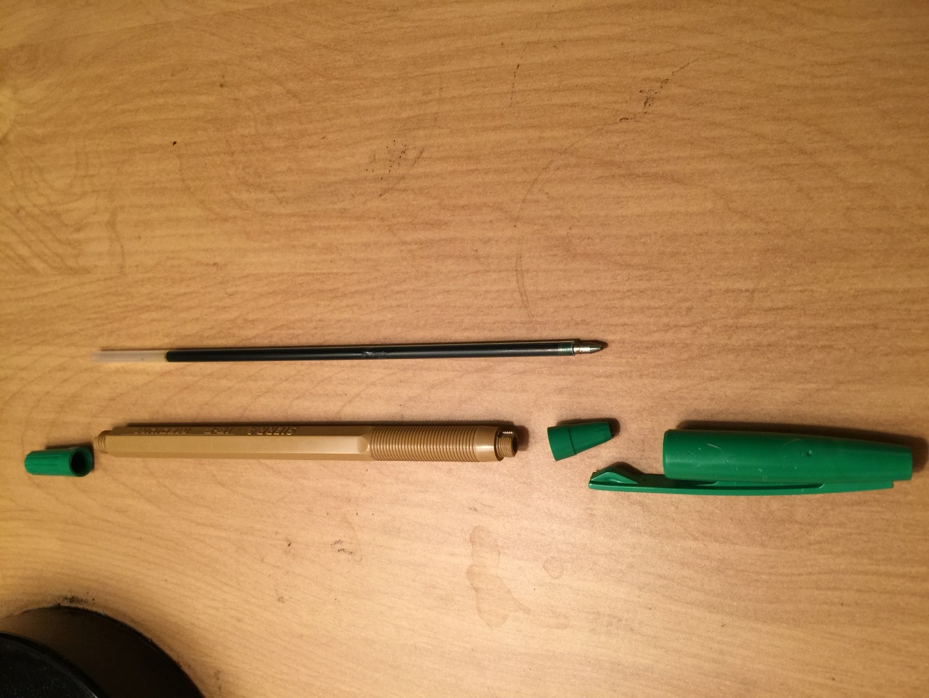

THE INK PEN WORKS BY HOLDING INK SO THAT WE CAN WRITE THINGS THAT WE NEED TO. THIS IS ACCOMPLISHED BY A CONTAINER THAT HOLDS THE INK CARTRIDGE IN PLACE WITH A CAP ON THE TOP PART OF THE CONTAINER THAT TWISTS ON AND A POINT ON THE BOTTOM PART OF THE CONTAINER THAT TWISTS ON AND HOLDS THE INK CARTRIDGE IN PLACE. AS AN ADDED CONVENIENCE, THERE IS ALSO A CAP THAT WILL GO OVER THE POINT OF THE PEN SO THAT INK DOES NOT GET TRANSFERRED ONTO ITEMS THAT IT SHOULD NOT BE PUT ON.

- Examine the spreadsheet below. Note that the design team has decided upon a rating for each of the four alternatives. Complete the weighted-rating calculations. Remember to convert the percentages to decimals before multiplying. Sum the weighted ratings for each candidate.
 | Concept Evaluation Using Weighted Rating Method (Pahl & Beitz Method)
 |  | Alternative Concepts / Embodiments
 |  | gears |  | v-belts |  | chain |  | linkages
Criteria | Weight (%) | rating | wt. Rating | rating | wt. Rating | rating | wt. Rating | rating | wt. Rating
cost | 20 | 3 | 0.6 | 4 | 0.8 | 4 | 0.8 | 4 | 0.8
weight | 15 | 2 | 0.3 | 4 | 0.6 | 3 | 0.45 | 4 | 0.6
size | 15 | 3 | 0.45 | 2 | 0.3 | 3 | 0.45 | 3 | 0.45
reliability | 9 | 4 | 0.36 | 3 | 0.27 | 4 | 0.36 | 4 | 0.36
efficiency | 8 | 4 | 0.32 | 3 | 0.24 | 4 | 0.32 | 3 | 0.24
force | 8 | 4 | 0.32 | 3 | 0.24 | 4 | 0.32 | 4 | 0.32
integral braking | 10 | 4 | 0.4 | 3 | 0.3 | 4 | 0.4 | 3 | 0.3
customer appeal | 15 | 2 | 0.3 | 1 | 0.15 | 4 | 0.6 | 3 | 0.45
 | 100 | na | 3.05 | na | 2.9 | na | 3.7 | na | 3.52
 | Unsatisfactory | 0
 | Just tolerable | 1
 | Adequate | 2
 | Good | 3
 | Very Good | 4

- Rank the alternatives based on their weighted rating?
CHAIN, LINKAGES, GEARS, V-BELTS
- Is there an obvious winner?
CHAIN
- Why?

THE CHAIN IS THE WINNER BECAUSE IT RECEIVED THE BEST RANKING BASED ON THE ABOVE TABLE.

- Let’s go back to your Lab 2. Based on your concept design, go online and do some research. Find some similar products. Compare with your concept design. Discuss what advantages and disadvantages of each (evaluate). Please post the pictures and the links of resource.

