OVERVIEW
The purpose of the plastic injection molding experiment was to accomplish many of the objectives of our course. It taught us how to measure using dial calipers, make a mold using the press, and it reinforced our understanding of how to use excel to make graphs. The goal of this experiment was to create 5 products using high density polyethylene pellets and 5 products using low density polyethylene pellets.

Procedure/ Steps

MATERIALS
- Mold cavity for the hand injection machine
- High Density Polyethylene bag of pellets
- Low Density Polyethylene bag of pellets
- Dial Caliper

EQUIPMENT
- Plastic Injection Molding Machine
- Safety Glasses

STEPS
- Obtain materials and equipment from the instructor.
- Locate the hand injection machine.
- Make sure the temperature is high enough to melt the plastic.
- Check the nozzle area for contamination and remove any excess plastic. (Be sure to not use your bare hand!)
- Place mold cavity into shot area and clamp into place. Make sure the nozzle and the inlet port are aligned.
- Put pellets in the heating chamber and wait a few minutes for them to melt.
- After they have melted, push down on the lever. Make sure to keep the pressure on the lever long enough to force the plastic into the mold.
- Remove the mold and measure the product’s diameter and thickness. Put this information in a table.
- Remember to purge the chamber as you move on to the next set of pellets.
- After you are done, you should have 10 products, 5 of each material. All of which are labeled.

Data Collection

Mold Diameter Measurement | 1.503
Mold Depth Measurement | 0.137

Sample Type | Measure 1 | Measure 2 | Measure 3 | Measure 4 | Measure 5 | Average
LD Hot Thickness | 0.138 | 0.130 | 0.142 | 0.151 | 0.145 | 0.141
LD Cold Thickness | 0.134 | 0.136 | 0.128 | 0.136 | 0.134 | 0.134
Difference | 0.004 | -0.006 | 0.014 | 0.015 | 0.011 | 0.008
HD Hot Thickness | 0.149 | 0.144 | 0.143 | 0.144 | 0.141 | 0.144
HD Cold Thickness | 0.149 | 0.145 | 0.147 | 0.143 | 0.137 | 0.144
Difference | 0 | -0.001 | -0.004 | 0.001 | 0.004 | 0
LD Hot Diameter | 1.454 | 1.447 | 1.420 | 1.510 | 1.499 | 1.466
LD Cold Diameter | 1.473 | 1.443 | 1.424 | 1.452 | 1.458 | 1.450
Difference | -0.019 | 0.004 | -0.004 | 0.058 | 0.041 | 0.016
HD Hot Diameter | 1.478 | 1.495 | 1.478 | 1.455 | 1.465 | 1.474
HD Cold Diameter | 1.458 | 1.436 | 1.450 | 1.424 | 1.441 | 1.442
Difference | 0.020 | 0.059 | 0.028 | 0.031 | 0.024 | 0.032

Conclusion

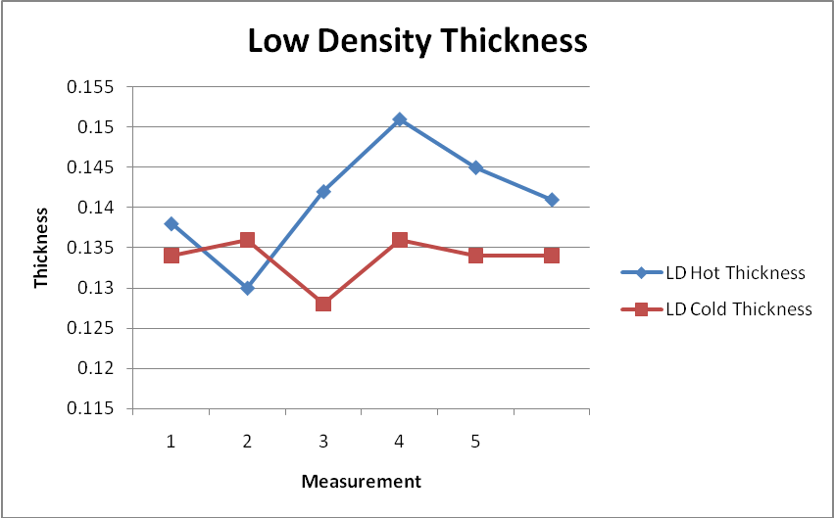

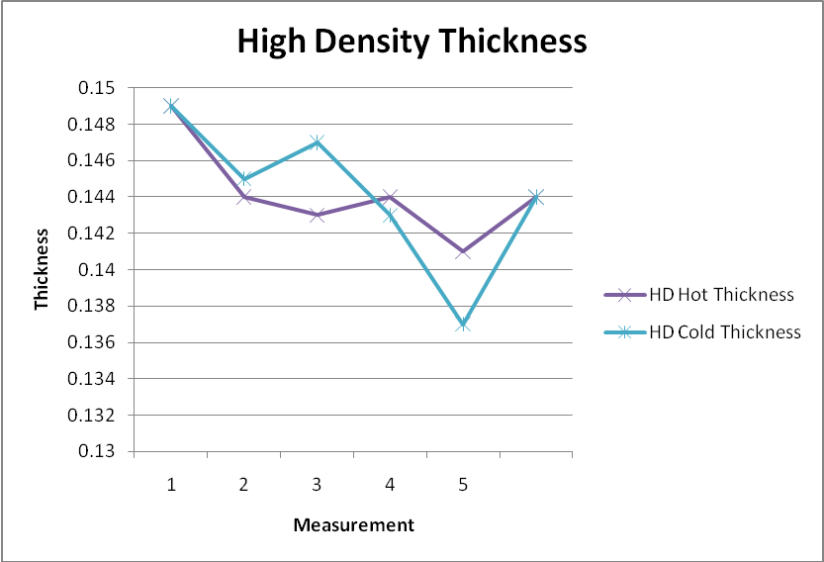

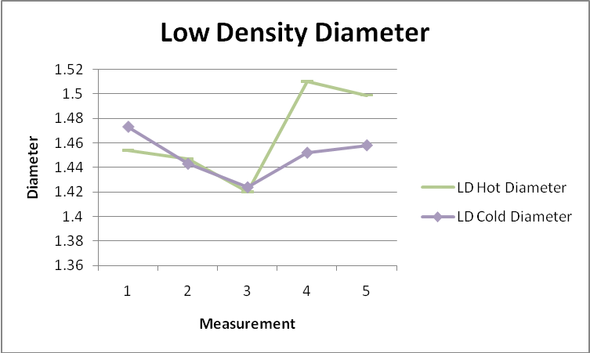

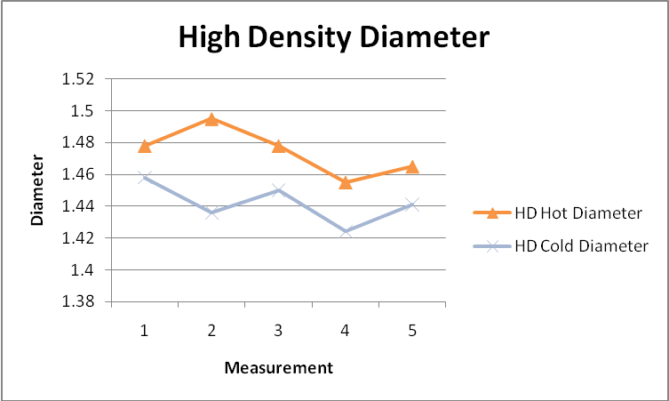

This experiment completed all of the objectives that it was supposed to complete. The graphs above demonstrate the information that we found in our experiment. It is conclusive to what was expected from this experiment. The diameter of the low density decreased as did the high density. The thickness also decreased with both polyethylenes as they cooled down. This is what I expected to happen with this experiment.

Technical Article Correlation

Plastic Bottle Corporation; plastic bottles, plastic jugs, plastic jars. Plastic Bottle Corporation; plastic bottle, plastic bottle manufacturer,plastic bottles, plastic jugs, plastic jars, plastic bottle manufacturers. Retrieved April 6, 2010, from http://www.plasticbottle.com/techinfo/article.html

This article talks about injection blow molding. This is a form of creating plastic bottles. In this process they use both low density and high density polyethylene to create their products. It relates to this experiment because you must first learn how to create a simple mold before you can understand the process that goes into a more complex mold that is involved in making plastic bottles.

