Chapter 1: User Interface
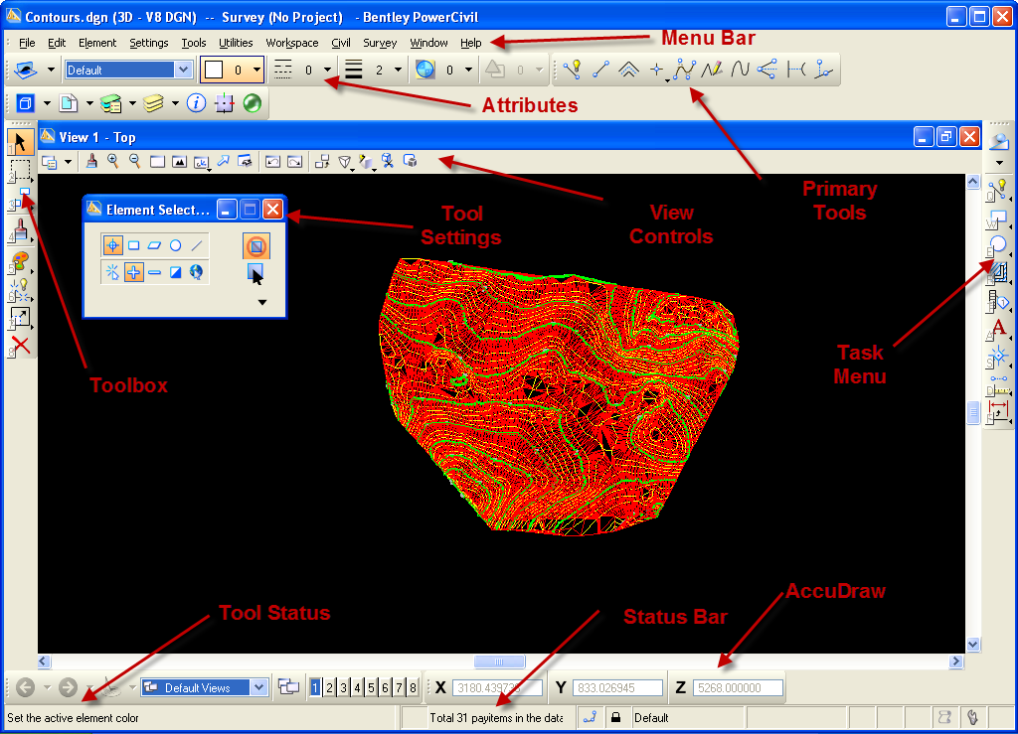
Figure 1: The Basic PowerCivil Window
Figure 1 shows the basic window inside of the PowerCivil software. The main elements of the window are labeled. These elements will be useful during the study of the PowerCivil software. The elements are broken into the following:
- Menu Bar: You will find familiar options in this menu. You will find file where you can save and print your drawing. There is also an edit menu where you will find options such as undo, copy, and paste. There are also PowerCivil specific menu in the main menu bar. These menus include settings, tools, utilities, workspace, civil, window, and help.
- Attributes: You can use this option to change line weights and colors.
- Primary Tools: This tool allows to you to create different levels. This tool works similar to layers in other CAD software.
- Toolbox: The toolbox contains various tools to manipulate elements within a drawing. These tools include delete, modify, and change attributes.
- Tool Settings: The tool settings dialog changes with each tool that you select. For example, if you choose to use the select tool, the tool setting would include options to select circles, lines, etc.
- View Controls: This tool allows you to manipulate the view of the drawing window. This allows you to zoom and fit the drawing to the window.
- Task Menu: The task menu has options to create lines, shapes, circles, multiline, and dimensions.
- Tool Status: The tool status describes the tool when you mouse over an icon. It also provides prompts as what to do next when you are using a tool.
- Status Bar: The status bar tells you what tool you are using and the status of the drawing window.
- AccuDraw: AccuDraw works similar to entity snap in other CAD software. AccuDraw will allow you to snap to a point if you hover your mouse close to a point.
User Preferences
To change you settings, go to Civil User Preferences. Figure 2 shows the user preference menu.
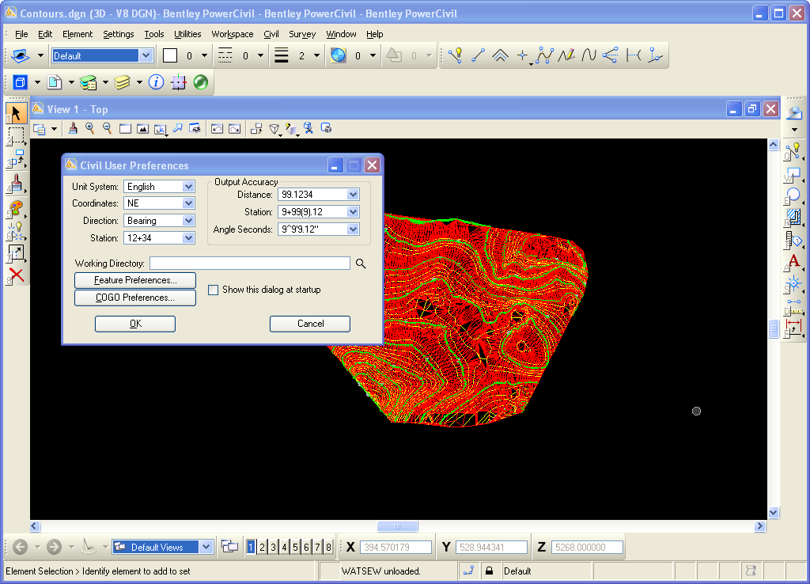
Figure 2: User Preferences Menu
This menu allows you to change your units, coordinates, bearing input, and output accuracy.

Chapter 2: Survey Data
PowerCivil offers a means to create visualization of survey point data. The survey tools allow you to enter X, Y, and elevations for each point obtained from a survey.
Example
In this example you will create the following figure.
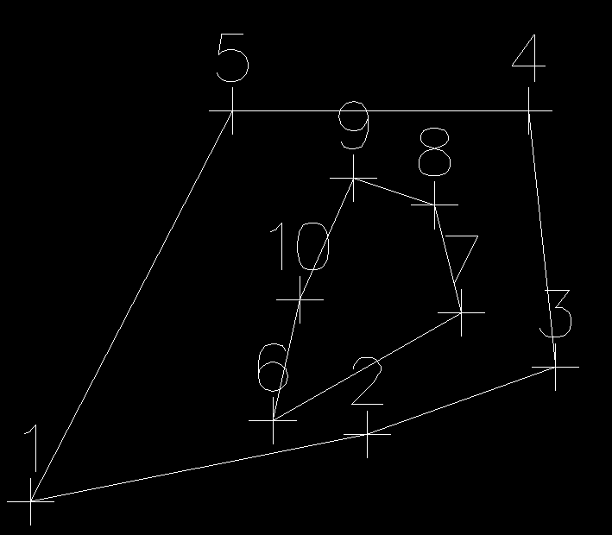
Figure 3: Example of Plotted Survey Points
Instructions:
You will use the following survey data to create this contour plot.
Point | X | Y | Z
1 | 16’ | 5’ | 10’
2 | 41’ | 10’ | 10’
3 | 55’ | 15’ | 10’
4 | 53’ | 34’ | 10’
5 | 31’ | 34’ | 10’
6 | 34’ | 11’ | 12’
7 | 48’ | 19’ | 12’
8 | 46’ | 27’ | 12’
9 | 40’ | 29’ | 12’
10 | 36’ | 20’ | 12’

To begin, you need to plot these points. To do this, go to Survey Project New.
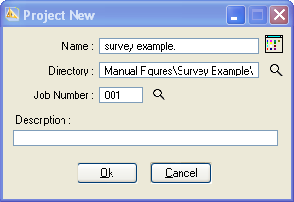
Figure 4: New Survey Project Window
Enter a name for the project. Set the save location using the Directory option. Now you are ready to begin plotting the survey points. You will begin by plotting points 1 through 5. Go to Survey Geometry Point Edit.
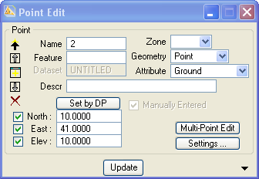
Figure 5: Point Creation
In the Point Edit window, you enter the name of the point. In this case, the name will be the point number. You then enter the North (Y), East (X), and Elevation (Z) coordinates. Press the update button and the point will be displayed in the graphical window. Do this for points 1 through 5.
You can now chain these points together. Go to Survey Geometry Chains Edit.
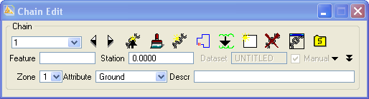
Figure 6: Chain Edit Menu
Click New Chain.
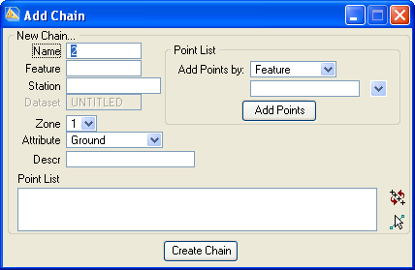
Figure 7: New Chain Creation
Enter a name for the chain. Click inside the Point List Box. Enter 1, 2, 3, 4, 5 . Press the Create Chain Button. You will be brought back to the Chain Edit Menu. Click the Close Chain Button to close the chain.
You can repeat these steps for points 6 through 10 to complete the drawing.
Activity
Create the following drawing using the given points.
Point | X | Y | Z
1 | 46 | 0 | 24
2 | 47 | 6 | 24
3 | 45 | 13 | 24
4 | 40 | 20 | 24
5 | 37 | 24 | 24
6 | 50 | 29 | 24
7 | 52 | 32 | 24
8 | 55 | 41 | 24
9 | 52 | 45 | 24
10 | 56 | 60 | 24
11 | 55 | 70 | 24
12 | 50 | 77 | 24
13 | 45 | 83 | 24
14 | 34 | 85 | 24
15 | 24 | 74 | 24
16 | 31 | 64 | 24
17 | 46 | 61 | 24
18 | 42 | 55 | 24
19 | 27 | 47 | 24
20 | 26 | 3 | 24
21 | 35 | 1 | 38
22 | 39 | 3 | 38
23 | 40 | 14 | 38
24 | 36 | 17 | 38
25 | 42 | 29 | 38
26 | 45 | 38 | 38
27 | 45 | 45 | 38
28 | 46 | 57 | 38
29 | 43 | 63 | 38
30 | 44 | 71 | 38
31 | 33 | 77 | 38
32 | 31 | 67 | 38
33 | 34 | 49 | 38
34 | 17 | 44 | 38
35 | 19 | 18 | 38
36 | 13 | 14 | 42
37 | 21 | 11 | 42
38 | 30 | 6 | 42
39 | 37 | 13 | 42
40 | 29 | 23 | 42
41 | 36 | 32 | 42
42 | 37 | 41 | 42
43 | 23 | 42 | 42
44 | 11 | 40 | 42
45 | 25 | 16 | 50
46 | 26 | 26 | 50
47 | 29 | 34 | 50
48 | 25 | 39 | 50
49 | 10 | 39 | 50
50 | 7 | 21 | 50

COGO
Another method to input survey data is using the coordinate geometry database (COGO). To use the COGO, create a new survey project. Go to Survey Geometry Graphical COGO.
Point | X | Y | Z
1 | 16’ | 5’ | 10’
2 | 41’ | 10’ | 10’
3 | 55’ | 15’ | 10’
4 | 53’ | 34’ | 10’
5 | 31’ | 34’ | 10’
6 | 34’ | 11’ | 12’
7 | 48’ | 19’ | 12’
8 | 46’ | 27’ | 12’
9 | 40’ | 29’ | 12’
10 | 36’ | 20’ | 12’

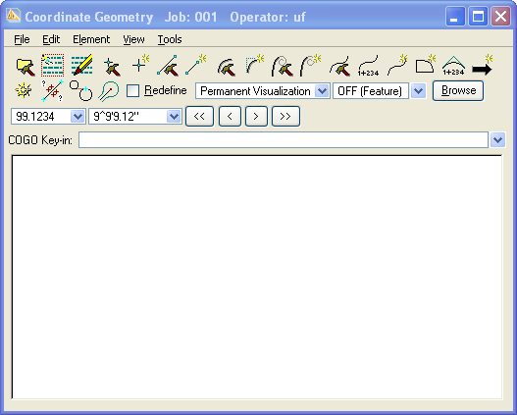
Figure 8: Graphical COGO Window
Click the Store Point icon.
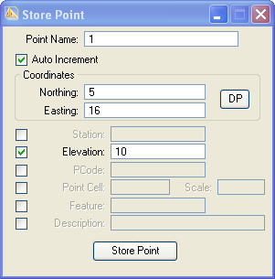
Figure 9: Store Point Window
In this window, enter the point name, Northing, Easting, and Elevation. After you enter two points, click the Store Line icon to create a contour line between points one and two.
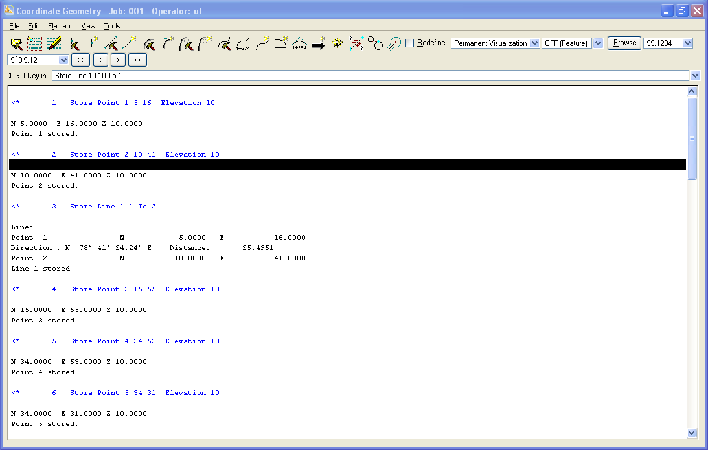
Figure 10: COGO Code
The COGO code provides useful information such as line bearing.
Activity
Create the following drawing using the given points and either the point input method or the COGO method.
Point | X | Y | Z
1 | 46 | 0 | 24
2 | 47 | 6 | 24
3 | 45 | 13 | 24
4 | 40 | 20 | 24
5 | 37 | 24 | 24
6 | 50 | 29 | 24
7 | 52 | 32 | 24
8 | 55 | 41 | 24
9 | 52 | 45 | 24
10 | 56 | 60 | 24
11 | 55 | 70 | 24
12 | 50 | 77 | 24
13 | 45 | 83 | 24
14 | 34 | 85 | 24
15 | 24 | 74 | 24
16 | 31 | 64 | 24
17 | 46 | 61 | 24
18 | 42 | 55 | 24
19 | 27 | 47 | 24
20 | 26 | 3 | 24
21 | 35 | 1 | 38
22 | 39 | 3 | 38
23 | 40 | 14 | 38
24 | 36 | 17 | 38
25 | 42 | 29 | 38
26 | 45 | 38 | 38
27 | 45 | 45 | 38
28 | 46 | 57 | 38
29 | 43 | 63 | 38
30 | 44 | 71 | 38
31 | 33 | 77 | 38
32 | 31 | 67 | 38
33 | 34 | 49 | 38
34 | 17 | 44 | 38
35 | 19 | 18 | 38
36 | 13 | 14 | 42
37 | 21 | 11 | 42
38 | 30 | 6 | 42
39 | 37 | 13 | 42
40 | 29 | 23 | 42
41 | 36 | 32 | 42
42 | 37 | 41 | 42
43 | 23 | 42 | 42
44 | 11 | 40 | 42
45 | 25 | 16 | 50
46 | 26 | 26 | 50
47 | 29 | 34 | 50
48 | 25 | 39 | 50
49 | 10 | 39 | 50
50 | 7 | 21 | 50

Chapter 3: Digital Terrain Modeling (DTM)

Chapter 2

